**K L UNIVERSITY**

**FRESHMAN ENGINEERING DEPARTMENT**

**A Project Based Lab Report**

**On**

**FOOD ORDERING**

**SUBMITTED BY:**

I.D NUMBER NAME

2010030471 ASHA ARIKA SUSMITHA

2010030558 SAI KOWSHIK GOUD

2010030487 CHOOSHNITHA

2010030201 TELUGU ROHITH

**UNDER THE ESTEEMED GUIDANCE OF**

**DR. Anantha Reddy**

**PROFESSOR**



**KL UNIVERSITY**

HYDERABAD, DIST-R.R , India.

**DEPARTMENT OF COMPUTER SCIENCES ENGINEERING**



**CERTIFICATE**

This is to certify that the project based laboratory report entitled “**FOOD ORDERING**” submitted by Mr./Ms**. SAI KOWSHIK GOUD** bearing Regd. No. **2010030558** to the **COMPUTER SCIENCES ENGINEERING, KL University** in partial fulfillment of the requirements for the completion of a project in “Enterprise Programming-19CS1203”course in III B Tech I Semester, is a bonafide record of the work carried out by him/her under my supervision during the academic year 2022-23.

PROJECT SUPERVISOR HEAD OF THE DEPARTMENT

DR. Anantha Reddy DR. Anantha Reddy

**ACKNOWLEDGEMENTS**

It is great pleasure for me to express my gratitude to our honorable President **Sri. Koneru Satyanarayana**, for giving the opportunity and platform with facilities in accomplishing the project based laboratory report.

I express the sincere gratitude to our Principal **Dr. L. Koteswara Rao** for his administration towards our academic growth.

I express sincere gratitude to our Coordinator and HOD-BES DR. Anantha Reddy for her leadership and constant motivation provided in successful completion of our academic semester. I record it as my privilege to deeply thank for providing us the efficient faculty and facilities to make our ideas into reality.

I express my sincere thanks to our project supervisor DR. Anantha Reddy for his/her novel association of ideas, encouragement, appreciation and intellectual zeal which motivated us to venture this project successfully.

Finally, it is pleased to acknowledge the indebtedness to all those who devoted themselves directly or indirectly to make this project report success.

Name: SAI KOWSHIK GOUD

Regd . No: 2010030558

**ABSTRACT**

1. ONLINE FOOD DELIVERY SYSTEM is a website designed primarily for use in the food delivery industry.
2. This system will allow hotels and restaurants to increase scope of business by reducing the labor cost involved.
3. The system also allows to quickly and easily manage an online menu which customers can browse and use to place orders with just few clicks.
4. Restaurant employees then use these orders through an easy to navigate.
5. Graphical interface for efficient processing.

|  |  |  |
| --- | --- | --- |
| **S.NO** | **TITLE** |  |
| 1 | ABSTRACT |  |
| 2 | INTRODUCTION |  |
| 3 | WHAT WE WILL DO |  |
| 4 | FEATURES |  |
| 4 | MODULES |  |
| 6 | ADVANTAGES |  |
|  |  |  |
|  |  |  |
|  |  |  |

**INTRODUCTION**

1. **Online ordering system that I am proposing here, greatly simplifies the ordering process for both the customer and the restaurant.**
2. **System presents an interactive and up-to-date menu with all available options in an easy to use manner.**
3. **Customer can choose one or more items to place an order which will land in the Cart.**
4. **Customer can view all the order details in the cart before checking out.**
5. **At the end, customer gets order confirmation details.**
6. **Once the order is placed it is entered in the database and retrieved in pretty much real time**
7. **This allows Restaurant Employees to quickly go through the orders as they are received and process all orders efficiently and effectively with minimal delays and confusion**

**SYSTEM REQUIREMENTS**

* **SOFTWARE REQUIREMENTS:**

The major software requirements of the project are as follows:

Language : JAVA

Operating system**:** Windows XP or later.

Tools: Eclipse IDE

* **HARDWARE REQUIREMENTS:**

The hardware requirements that map towards the software are as follows:

RAM : 8 GB

Processor : i3 INTEL CORE

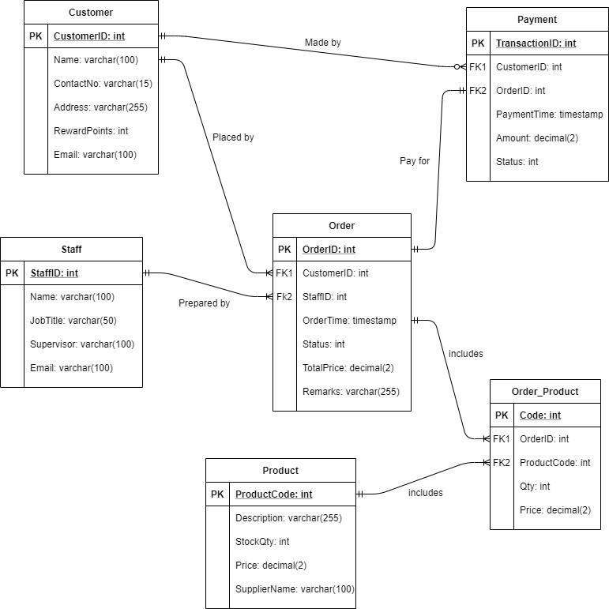

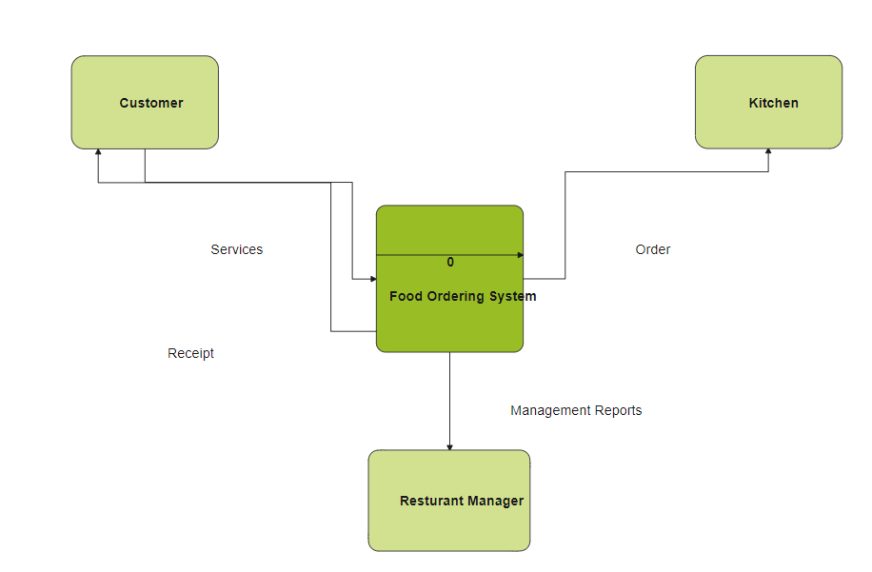

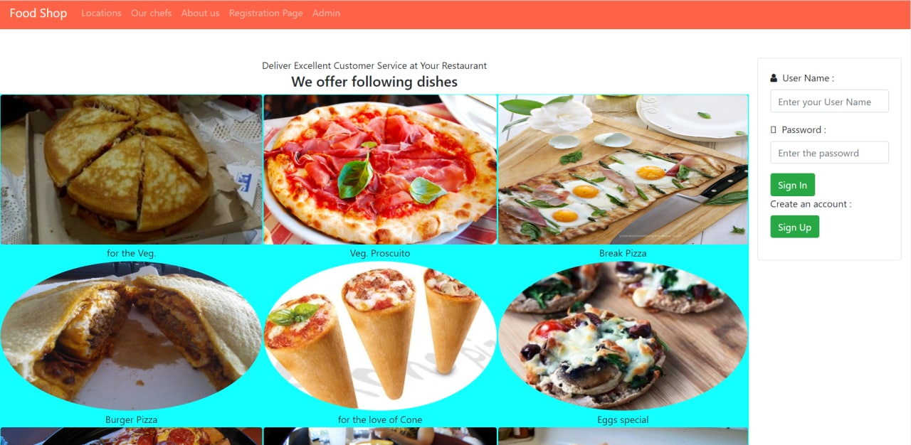

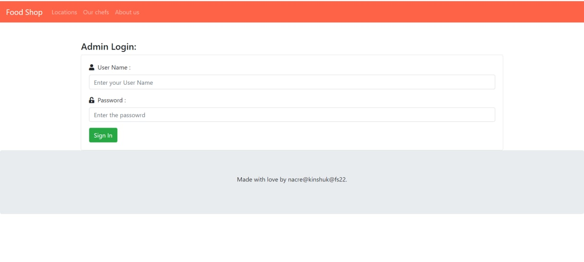

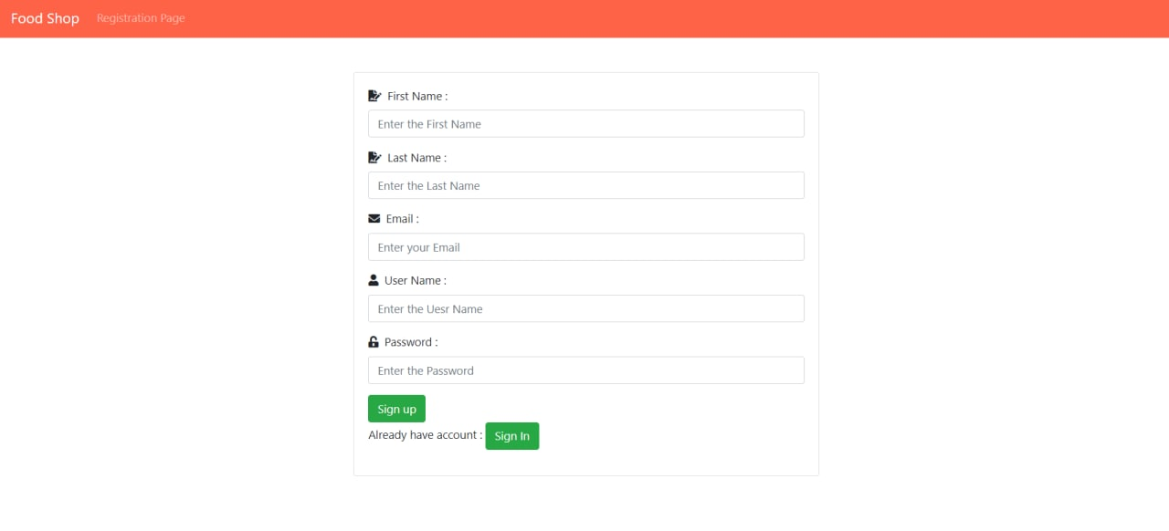

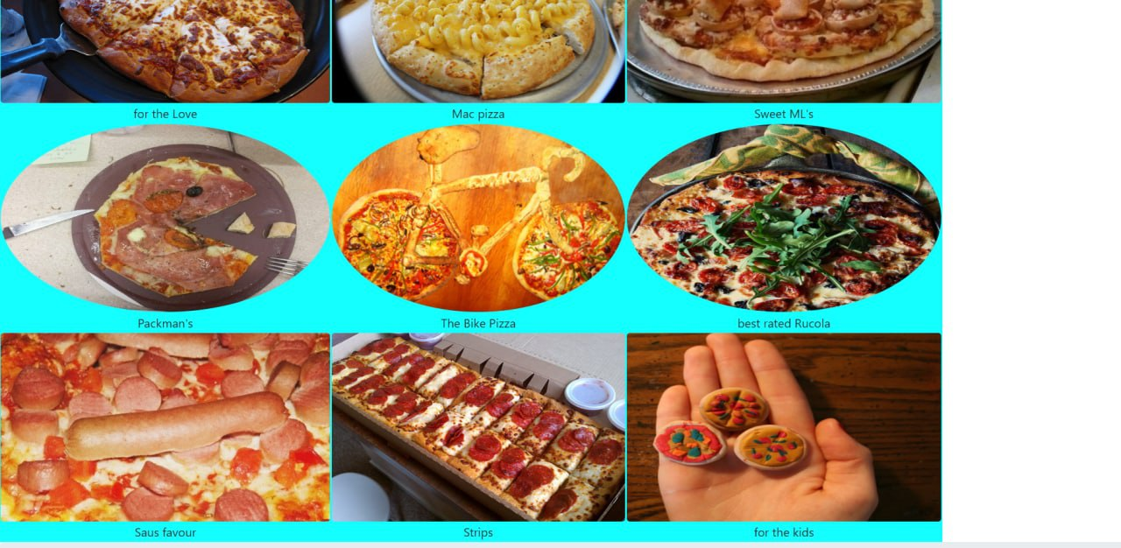

**CONCLUSION**

**& Future Work**

After we have completed the project we are sure the problems in the existing system would overcome. The “FOOD ORDERING” process made computerized to reduce human errors and to increase the efficiency. The main focus of this project is to lessen human efforts. The maintenance of the records is made efficient, as all the records are stored in the ACCESS database, through which data can be retrieved easily. The navigation control is provided in all the forms to navigate through the large amount of records. If the numbers of records are very large then user has to just type in the type in the required field and press the update button to update the desired field.

The FOOD ORDERING allows the user to order the food details and the person’s details. • This software allows storing the details of all the data related to food . • The implementation of the system will reduce data entry time and provide readily calculated reports.

The food odering software is a highly reliable, user-friendly software that performs all tasks for a costumer and makes food order quick and convenient. This software stores, organizes, shares and retrieves all data essential to perform day-to-day operations of the library.

* It is not possible to develop a system that makes all the requirements of the user. User requirements keep changing as the system is being used. Some of the future enhancements that can be done to this system are:
* As the technology emerges, it is possible to upgrade the system and can be adaptable to desired environment.
* Based 0n the future security issues, security can be improved using emerging technologies .
* Sub admin module can be added